Enhancing Fitness Performance and Reducing Injury Risk Through Real-Time Wrist and Hand Posture Monitoring with IMU Sensors

Matthew Keller
Seminar in Computer Science
Dr. Andrea Tartaro
May 1, 2025

INTRODUCTION
In the field of fitness, specifically weightlifting, injuries due to improper lifting form are highly prevalent. This is a concern for both new and experienced lifters, as both may lack the necessary knowledge to execute lifts properly. They may also have simply been exposed to misinformation that encourages poor lifting form. As social media continues to grow, information relating to fitness is becoming more accessible to both creators and consumers. While this has been beneficial for many in receiving content that promotes health and well-being, those same individuals are at a much greater risk of being subject to misinformation. A study conducted in Brazil found that only 2.7% of fitness-related posts cited scientific sources, and only 39% of creators had academic or professional degrees (Maracolo et al. 2021). This suggests that those interested in fitness receive information that is often not backed by science. If this anecdotal information is utilized in the gym, it may result in improper form.
The use of improper form may lead to several issues, including injury and loss of power output. Even if injury is not immediate, improper form can cause the lifter to favor one side during their exercise. Constant favoring of one side will cause imbalanced development of the muscles, putting excess pressure on joints and muscles. A systematic review of muscular imbalances and injury rate found “significant correlation between muscle imbalance and damages such as lower back, shoulder, wrist, and elbow injury among overhead athletes” (Kamalden et al. 2021, 120). These injuries can affect the entire musculoskeletal system and induce chronic pain (Kamalden et al. 2021). Muscular imbalance is hard to detect, even for experienced weightlifters. It may not become apparent until there is a visible difference in muscle size or the imbalance causes an injury to occur. Therefore, it is vital to a lifter’s long-term muscular health to be aware of any improper technique when dealing with high-risk areas of the body.
The wrists and hands are highly susceptible to injury; 15.3% of total weightlifting injuries are to the hand and fingers (Tung et al. 2024). These injuries are often caused by incorrect wrist and hand orientation and are preventable with correct information and proper coaching. Additionally, if the weightlifter maintains proper wrist position, they could achieve more power output. Any deviation from neutral wrist position under stress from excess weight not only increases injury risk but also puts physical strain on the hand rather than the entire arm. As a result, the muscles in the forearm are no longer properly engaged, and power output is lost (Roman-Liu and Bartuzi, 2013). Therefore, it is important for lifters to ensure that proper wrist posture is maintained to avoid injury and maximize power output. To address this issue, I have created a cost-effective solution that utilizes inertial measurement units to track the position of the hands and wrist to provide real-time feedback and prevent the lifter’s wrist from entering an unsafe position.
The goal of this project is to create a hand-secured sensor that uses both positional and orientational data to ensure proper form is utilized in the wrist and hand during barbell movements. Data is collected based on the wrist position detected by the sensor. Feedback is immediately returned to the user in the form of a buzzer that will notify them if their hands or wrists leave a safe range. This has the potential to promote longevity in competitive athletes and casual lifters alike by ensuring that proper form is utilized throughout the duration of the lift. As a byproduct of proper lifting form, the lifters can potentially push harder physically, making this an effective tool to optimize the power output of casual and competitive weightlifters.
In what follows, there is a discussion on the motivating knowledge that serves as the foundation of the project, such as existing IMU-based fitness sensing equipment, and the methodology of this project including the exact materials utilized in order to complete this project, as well as the algorithms used for sensor fusion and noise reduction. Then there is information on the code used to process the data, as well as challenges that arose during the project and areas of future improvement. Finally, there is discussion on the accuracy of the results and how this project provides the foundation for an affordable approach to wrist and hand sensing.
BACKGROUND
Previous research explores the use of fitness sensors to serve a variety of different purposes. Fitness sensors are any electronic devices that track body position or motion to provide feedback to athletes. Many of these devices have proved their usefulness and have made it onto the market. Examples of such sensors include the Beast Sensor, which can either be worn as a wristband or attached directly to the barbell. This device was developed in order to track the velocity of repetitions of exercises (Mitter et al. 2021). The primary purpose of this sensor is to track the amount and speed of repetitions; however, it does nothing to correct lifting form. Furthermore, many of these velocity sensors can introduce a high level of error due to their limited use of sensors, devices, and information (Külkamp et al. 2024).
Other sensors and technology provide real-time form coaching. These are electromyography (EMG)-based systems that require the user to wear electrodes on the targeted muscle to determine activation level (Martin-Fuentes et al. 2020). Not only are these systems typically very expensive and require a professional to apply the electrodes to the correct muscles, but they are also not practical for daily use and hinder the weightlifter from completing their workout comfortably.
Finally, applications use a combination of a camera and AI-powered software to create a skeleton of the user and conduct motion tracking to ensure that proper form is used (Ashraf et al. 2024). While this can be relatively effective for overall body form, it is ineffective in measuring errors in specific, smaller areas of the body, such as the wrist and hands. These AI-driven methods do not have the capability to track the hand and wrist at all, or would need a direct view, which is sometimes not possible or convenient (Pawar et al. 2023). Other solutions rely primarily on motion capture technology, but these solutions have their issues. Often, motion capture can introduce an even higher margin of error and requires a large amount of setup and can often be costly (Vithanage et al. 2018). Even then, the accuracy of smaller body parts such as the hands and wrists would provide a high margin of error. These current weightlifting specialized sensors focus primarily on velocity tracking, repetition counting, or full-body posture corrections. While they are effective in promoting good exercise habits, they are not precise enough to provide accurate information on the wrists or hands needed for form coaching.
There is precedent for positional and orientation tracking for fitness sensing, specifically dealing with inertial measurement units or IMUs, which are electronic devices that track the device’s force and position. Research suggests that IMUs are highly precise when used in fitness watches currently on the market or in development (Hausberger et al. 2016). It is clear that using gyroscopic measurements, such as those in the Beast Sensor, body orientation can be calculated. This has not been done with a focus on wrist position for barbell lifts. Therefore, this sensing system focused on hand and wrist position is possible given the current sensors on the market and data collection using IMUs.
MATERIALS AND PROJECT
To complete this project, a variety of different sensors and components are required. The development board used for this project is the Arduino Nano 33 BLE Rev2, pictured in Figure 1. It features a built-in 9-axis IMU with an accelerometer, gyroscope, and magnetometer. These are essential in detecting the orientation of the wrists and hands.
The device can be operated wirelessly for a better user experience. The orientational and positional data of the device is calculated; if it deviates a sufficient amount (within 20 degrees) from the safe neutral wrist position, an alert will be sent back to the user in the form of audio feedback. To achieve this audio feedback, a 3-volt Piezo buzzer has been attached to each device that produces up to a 100 dB tone to alert the user of their error. A 9-volt rechargeable battery is attached to the device to ensure that it can be used wirelessly. The rechargeable battery can be detached and recharged. Additional components include DuPont wires to connect the components and a button switch to activate the code that enables this device.
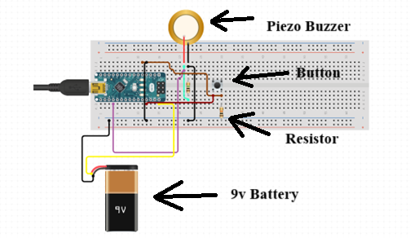
Figure 2. Final blueprint for the components of the device
Figure 2 depicts the complete blueprint of the device with the 9V battery, button, and Piezo buzzer. The final device is secured in a custom-built protective 3D printed case that is attached to a lifting glove. This blueprint is sourced from user cjake on Thingiverse and edited using Tinkercad using dimensions from the components utilized in this device. I removed parts of the lid for there to be sufficient room for the wiring. I also added two ledges on the bottom of the case to support the Piezo buzzer and 9V battery when mounted. This custom design allows for the case to be compact and comfortably fit on the lifter’s hand while also enabling easy access to remove the 9-volt battery for recharging.
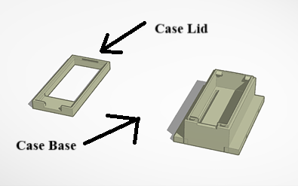
Figure 3. Blueprint for the 3D printed case for the device
Figure 3 shows the customized 3D printed protective case for the device. Placing the sensor directly on the hand in a glove allows for the position of both the hand and wrist to be measured accurately and ensures that the least amount of error in positioning (Harrison et al. 2025).
To achieve positional and orientational tracking, an Attitude and Heading Reference System (AHRS) package developed by David Such was used in conjunction with code I developed in C++. Using Madgwick’s algorithm function built into Reefwing-AHRS, I am able to take the raw data from the gyroscope, accelerometer, and magnetometer and combine it to get accurate orientational data in the form of Euler angles (Jitpakdeebodin et al. 2024). This algorithm is considered to be relatively lightweight in comparison to other sensor fusion algorithms and is the best option for providing real-time feedback to the user. The Euler angles output from Madgwick’s algorithm are compared to the expected safe range (20 degrees from neutral) within my code (Jitpakdeebodin et al. 2024). Finally, a response from the Piezo buzzer is returned to the user if there is an issue in the lifter’s form. The total cost for this project is $60. The development board in its header-less version costs $26. The rechargeable 9V battery costs $5. The Piezo buzzer costs $3. The DuPont wires and buttons cost $8. The battery connecting wire is $3. Finally, the gloves cost $15.
METHODOLOGY AND CODE
In order to process the data coming from the sensors onboard this device, I developed software in C++. I used the Arduino BMI270 and BMM150 packages to access the 6-axis gyroscope and accelerometer, as well as the 3-axis magnetometer. This allows for these sensors to be activated upon button press. I utilized David Such’s Reefwing-AHRS package to take data from the IMU and turn it into pitch, yaw, and roll angles (Euler) using Madgwick’s algorithm. Pitch is rotation on the X-axis, while roll is rotation on the Y-axis, and yaw is rotation on the Z-axis. Reefwing-AHRS also filters the data to minimize noise in the sensor data and helps with the calibration of the sensors.
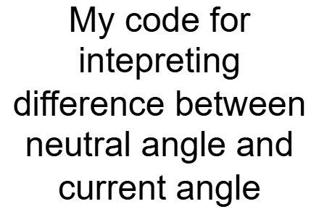
Figure 4. Madgwick’s algorithm visualization pipeline
Once the Euler angle data is available, the code I developed then continues to loop to constantly check the state of the device. The code is ensuring that as the device moves and new data comes in, it does not enter an unsafe angle with a certain margin of error in place to mitigate tone activation due to sensor error. Figure 4 details the pipeline that dictates the process by which the data is handled. There exists some sensor inaccuracy, therefore, to prevent the device from producing a tone when unnecessary, a 20-degree tolerance was introduced in the code. I chose 20 degrees for tolerance as I found that this was the optimal range to prevent false positives while also retaining the efficiency of the device. If the lifter’s hands and wrist enter an unsafe angle, a signal is sent to the Piezo buzzer to emit a tone until the device once again enters a safe angle. The final product is housed in the 3D printed case that I modified to properly fit the button and Piezo buzzer necessary for this project.
RESULTS
The finished device features a low-profile set of components connected with DuPont wires. I soldered all components directly to the development board to reduce weight and ensure that the device remains small enough to fit smaller hands and wrists. I designed the case to be disassembled, and the 9-volt battery can easily be removed for charging. When the battery is connected, the device’s onboard green LED turns on, indicating the device is ready for use. Once the button switch is pressed, the code runs, and the lifter can begin their exercise. If at any point throughout the lift the weightlifter’s hands and wrists enter an unsafe range, the Piezo buzzer will produce a noise. Once the lift is complete, the weightlifter can once again press the button on the device to deactivate the program.
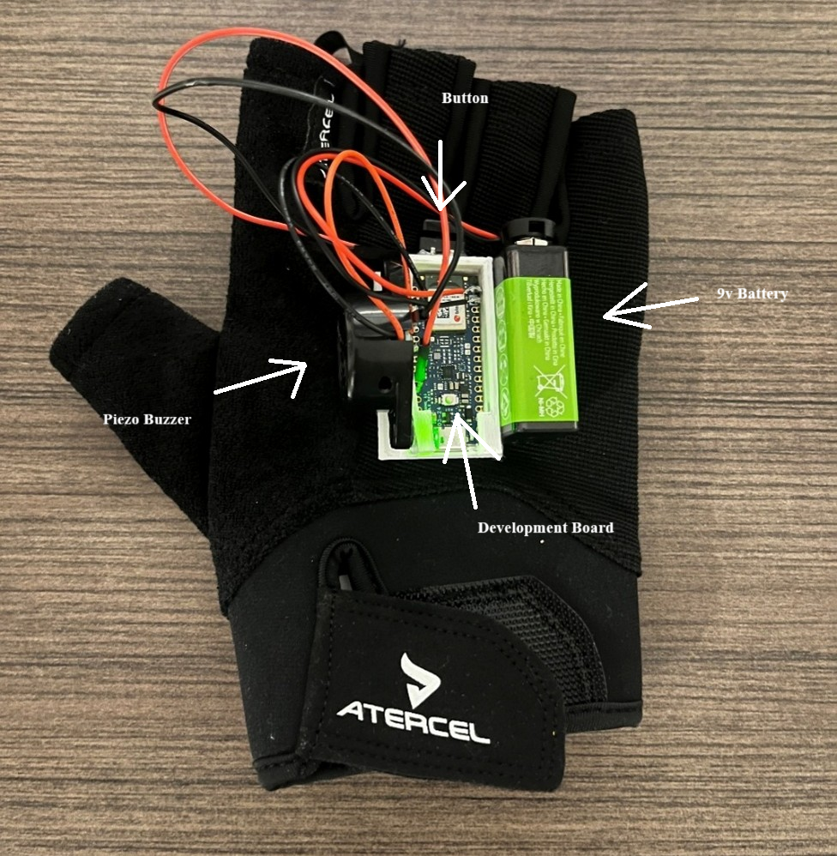
Figure 5. Final assembled device
Figure 5 depicts the assembled device. On the left side, I attached the Piezo buzzer to the case of the development board. On the right side, I attached the 9V battery for wireless use and as a counterweight to the Piezo buzzer. Finally, on top, there is a button to start and stop the program.
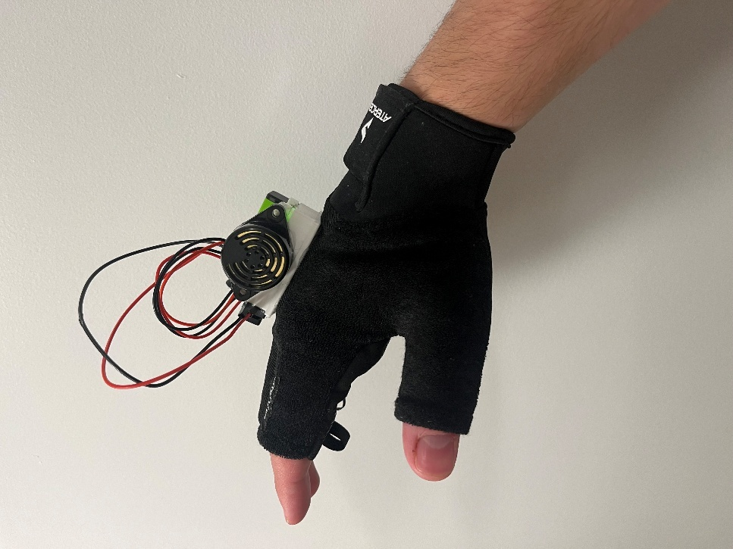
Figure 6. Final glove-mounted device in a 3D printed case modeled on a hand in an unsafe wrist position.
Figure 6 demonstrates the wrist position that would be considered unsafe and thus would trigger the device. In this case, the device would produce a tone until the weightlifter moved their wrist into the neutral range.
CHALLENGES
Several roadblocks were encountered throughout the completion of this project. The first challenge that arose was part selection. A 9-axis IMU was required for orientational data. There are many development boards that feature 9-axis IMUs, and other setups that could have an external IMU soldered to the development board. The final design included a development board that had an integrated 9-axis IMU in order to reduce latency as much as possible, as well as keep the device as compact as possible.
The next roadblock was due to the inaccuracy of uncalibrated sensors. When utilized directly out of the box, sensors lack the necessary spatial data to track precise movements. If the sensor is moved, the data reported will be amplified, leading to inaccurate readings. In order to compensate for this, I performed sensor calibration, which included executing certain tasks with the sensor in hand, such as moving the sensor in a circular motion to give the device sufficient positional data. The sensor also required additional data, such as the magnetic declination in the area of development.
Attempting to keep the small form factor also provided some challenges. It was important to keep the device small enough that it would fit most lifters. A header-less version of the Arduino development board was used so that the board could be attached directly to its casing to save room. This made attaching components and wires much more difficult, as I did not have the headers to attach the wires to. The case was designed with size in mind, giving just enough space to house all of the components while still being functional.
The final challenge encountered was properly interpreting the Euler angle results from Madgwick’s algorithm. The original design featured an ultra-wideband module that allows for relative position. The intended purpose of this addition was to allow for the devices’ relative position to be tracked in order to ensure one hand was not above the other during an exercise. There were several issues with this design, most notably the 10cm margin of error that existed with these devices. Since this project is concerned with small deviations in hand and wrist position, this error was too great to be included in the final device. Instead, I opted to use a single device on the right hand to achieve the highest possible accuracy and the simplest design while still fully capturing the position of the hand and wrist.
IMPLICATIONS
This project has the potential to be highly impactful for the general lifting community. This system allows the average lifter to have access to a device that can provide real-time feedback on form for a high-risk body part for approximately $60. Typically, to have access to this information, weightlifters would either go to a business that has access to expensive EMG or complex sensing systems or hire a knowledgeable coach. Now, it will be possible to own a system that can achieve a similar goal and track progress over time for a fraction of the cost. This would allow both new lifters and experienced weightlifting athletes to guarantee that proper wrist form is being used over time, promoting longevity and minimizing the chance of injury. Those who are aware of a muscular imbalance or are made aware of it by this device could utilize this device over time to be conscious of their bias towards one side. Over time, this may allow for the muscular imbalance to be corrected. This project may also help competitive athletes optimize power output. With this device constantly measuring their wrist position, they would be able to ensure optimal form for power output to engage all necessary muscles in the forearm.
This project also sets a precedent for form detection with IMU systems for smaller muscle groups. In the future, precise tracking could be done on areas of the body such as the fingers, ankles, and knees, all of which are prone to injury and may benefit from IMU assisted form coaching (Tung et al. 2024). This device may also have the potential to be helpful in the medical field. Patients undergoing the process of rehabilitation for their wrist after injury or surgery could use a similar device to ensure they are maintaining proper posture throughout the day. This has the potential to greatly speed up recovery time and reduce complications. Therefore, this project presents a novel, cost-effective solution to an important issue in the lifting community that can often cause career-ending injuries. With the capability to optimize performance and reduce the risk of injury, this project has the potential to be an impactful development for the safety of lifting and proper hand and wrist posture.
CONCLUSION
This project demonstrates that it is possible to utilize IMU technology to monitor wrist and hand position and provide real-time feedback during lifts with an affordable system. Through the hardware on the development board, software built to convert raw sensor data to Euler angles, and the custom case, this device offers an accessible alternative to professional form coaching. The system provides real-time feedback that is easily noticeable by the weightlifter. This encourages immediate correction, which has the potential to reduce the risk of injury and enhance athletic performance by maintaining optimal biomechanics throughout the duration of the lift (Roman-Liu and Bartuzi, 2013).
Future work on this device could include more precise sensors with less error. Machine learning algorithms could be utilized in order to detect when the lifter is beginning their set in order to mitigate the Piezo buzzer activating before and after the exercise set, and remove the need to turn the sensors on and off between sets. Integration for more exercises could also be accomplished, with an interface through a mobile app or computer program that allows the weightlifter to select their exercise and have the code change the assumed safe angles to allow for coaching for that specific movement, such as squat or curl. The interface could also show changes in overall lifting patterns over time by using the device to track progress. Finally, integrating an LED that displays the current battery charge would allow the user to know when their device is going to run out of battery.
Ultimately, this project provides a foundation for utilizing IMUs for affordable form tracking in areas that require precise measurements, making injury prevention and performance enhancement more accessible to all lifters.

Bibliography
Ashraf, Ahsan, and Talha Shahid. n.d. 2024. “AI Fitness Trainer.” ResearchGate. https://doi.org/10.13140/RG.2.2.29212.30089.
cjake. Arduino Nano 33 BLE Sense Box. Thingiverse. Accessed April 30, 2025. https://www.thingiverse.com/thing:4801467.
Roman-Liu, Danuta, and Paweł Bartuzi. 2013. The influence of wrist posture on the time and frequency EMG signal measures of forearm muscles, Gait & Posture, Volume 37, Issue 3, 2013, Pages 340-344, ISSN 0966-6362, https://doi.org/10.1016/j.gaitpost.2012.07.027.
Harrison, Amy, Andrea Jester, Surej Mouli, Antonio Fratini, and Ali Jabran. 2025. “Systematic Evaluation of IMU Sensors for Application in Smart Glove System for Remote Monitoring of Hand Differences.” Sensors 25 (1). https://doi.org/10.3390/s25010002.
Hausberger, Peter, Andreas Fernbach, and Wolfgang Kastner. 2016. “IMU-based Smart Fitness Devices for Weight Training.” IEEE. IECON 2016 42nd Annual Conference of the IEEE Industrial Electronics Society.
Jitpakdeebodin, Songchai, Phurin Nararat, Phonlawat Duangtoi, Kanjana Eiamsaard, and Pongsakon Bamrungthai. 2024. “IMU-Based Motion Capture Using Madgwick Filter with 3D Visualization for Robot Teleoperations.” In 2024 9th International Conference on Control and Robotics Engineering, ICCRE 2024, 121–26. Institute of Electrical and Electronics Engineers Inc. https://doi.org/10.1109/ICCRE61448.2024.10589761.
Kamalden, Tengku Fadilah Tengku, Qais Gasibat, Shamsulariffin Samsudin, and Jacklyn Anak Joseph. 2021. “Occurrence of Muscle Imbalance and Risk of Injuries in Athletes Using Overhead Movements: A Systematic Review.” Sport Mont. Montenegrin Sports Academy. https://doi.org/10.26773/smj.211012.
Külkamp, Wladymir, Chris Bishop, Rafael Kons, Lara Antunes, evertoncrivoi Carmo, Deborah Hizume-Kunzler, and Juliano Dal Pupo. 2024. “Concurrent Validity and Technological Error-Based Reliability of a Novel Device for Velocity-Based Training.” Measurement in Physical Education and Exercise Science 28 (1): 15–26. https://doi.org/10.1080/1091367X.2023.2207570.
Marocolo, Moacir et al. “Is Social Media Spreading Misinformation on Exercise and Health in Brazil?” International journal of environmental research and public health vol. 18,22 11914. 13 Nov. 2021, doi:10.3390/ijerph182211914
Martín-Fuentes, Isabel, José M. Oliva-Lozano, and José M. Muyor. 2020. “Electromyographic Activity in Deadlift Exercise and Its Variants. A Systematic Review.” PLoS ONE 15 (2). https://doi.org/10.1371/journal.pone.0229507.
Mitter, Benedikt, Dominik H ¨ Olbling, Pascal Bauer, Michael Stöckl, St¨ Stöckl, Arnold Baca, and Harald Tschan. 2019. “Concurrent Validity of Field-Based Diagnostic Technology Monitoring Movement Velocity in Powerlifting Exercises.” www.nsca.com.
Pawar, Rahul, Bhavesh Dhake, Chinmay Chavan, Unnati Gohil, and Rasika Ransing. 2023. “‘AI FIT’ Virtual Gym With Real-Time Exercise Form Detection.” In Proceedings of 3rd International Conference on Advanced Computing Technologies and Applications, ICACTA 2023. Institute of Electrical and Electronics Engineers Inc. https://doi.org/10.1109/ICACTA58201.2023.10393059.
Such, David. Reefwing AHRS: Attitude and Heading Reference System library for Arduino. GitHub. Accessed April 30, 2025. https://github.com/Reefwing-Software/Reefwing-AHRS.​
Tung, Matthew Jia Yuan, George Alexander Lantz, Alexandre Dias Lopes, and Lars Berglund. 2024. “Injuries in Weightlifting and Powerlifting: An Updated Systematic Review.” BMJ Open Sport and Exercise Medicine. BMJ Publishing Group. https://doi.org/10.1136/bmjsem-2023-001884.
Vithanage, Sameera, Maneesha Ratnadiwakara, Damitha Sandaruwan, S M K D Arunathileka, Maheshya Weerasinghe, and Chathuranga Ranagsinghe. 2018. “A NOVEL APPROACH TO DETECT MUSCLE STRENGTH IMBALANCES VIA MOTION ANALYSIS USING SENSORY INPUTS.” European Journal of Computer Science and Information Technology 6 (5): 37–50. www.eajournals.org.

